Requirements for Message Triage Agent
- Power Platform Environment with Dataverse
- Copilot Studio Credits or Pay as you go configured * this agent is autonomous
- Message Center Sync to planner
Setup Planner: Take note of the M365 Group and Plan name as you will need this in later steps
The Planner Plan should have the following buckets configured:
- Informational
- Low
- Medium
- High
- Critical
Setup MC Sync to Planner: WARNING: If you are setting this up as a net new sync the 28 day option takes a long time – 7 recommended
Track message center tasks in Planner - Microsoft 365 - Microsoft Planner | Microsoft Learn
- When adding Planner Sync chose the to-do bucket (default)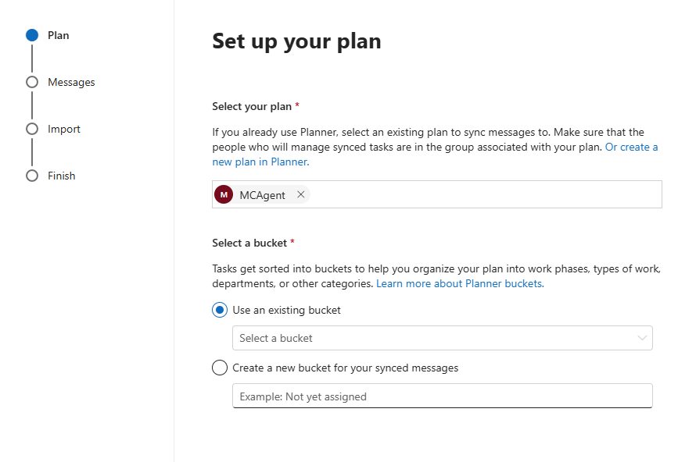

Adding the Agent to your environment:
- Navigate to copilotstudio.microsoft.com – Select your Power Platform Environment on the right hand side.
- Select the three dots on the left and choose “Solutions” 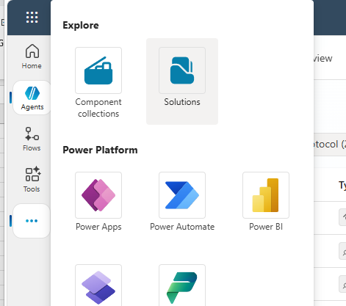
- Select the MessageCenterTriage.zip file and import 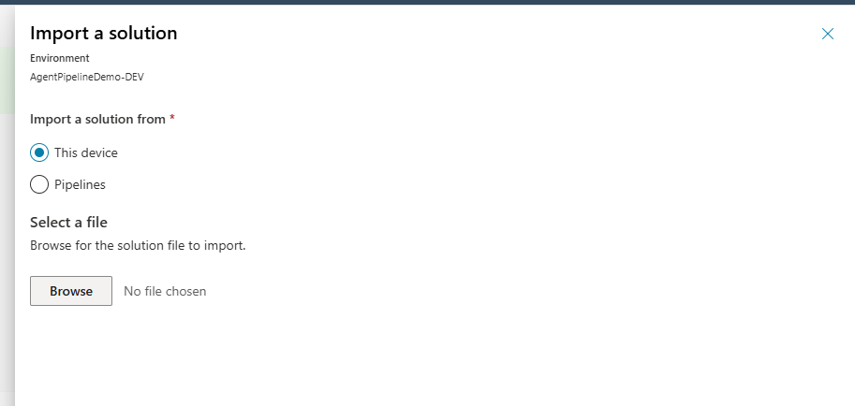
- Using the Included Workload Assignment excel file update the product owners and save the file.
- Navigate to make.powerapps.com > Tables > select the MCTeamAssignments table

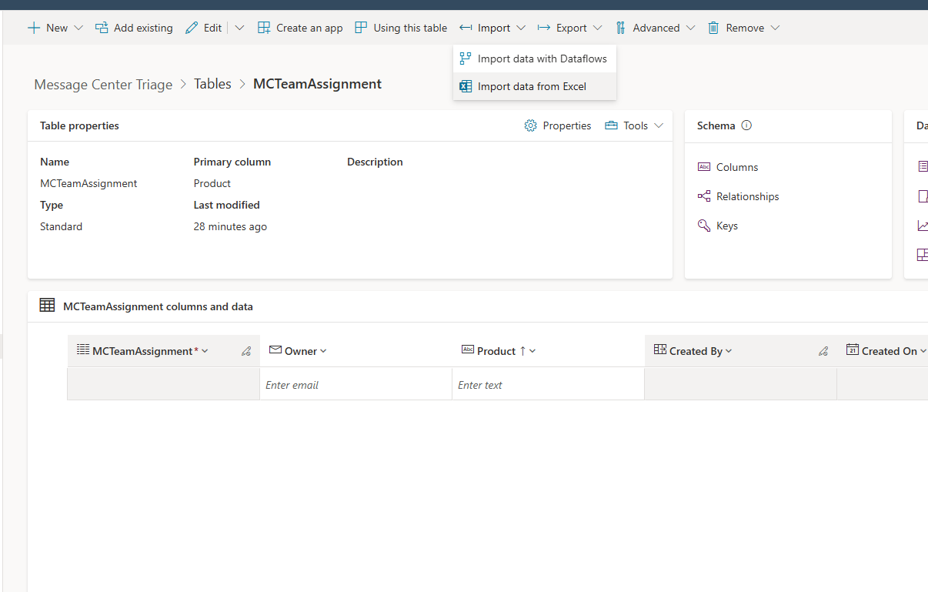
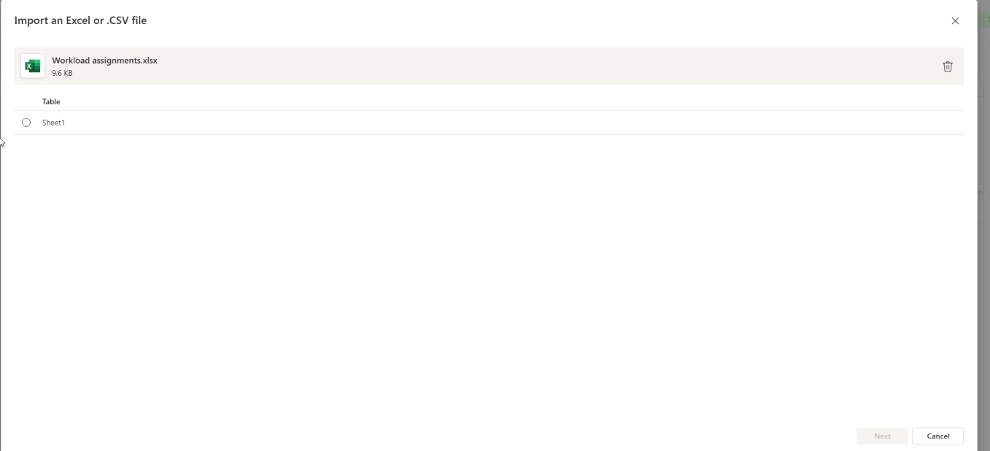

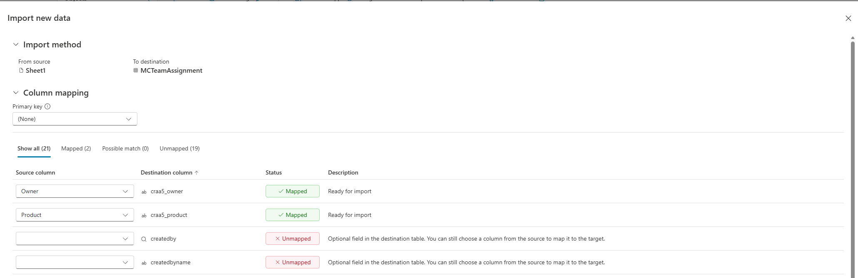
Select import > Import Data from Excel, select the excel file created in Step 4 and ensure the Product and Owner fields are mapped.

- Navigate to Copilot Studio and select the Message Center Triage Agent
Navigate to Tools & update the MessageCenterPlanner tool with the Group and Plan Name from the initial setup setups.
  - Update the GetPlannerBuckets tool with the Group name and Plan Name
  - Update the Get Plan Details tool with the plan ID of the plan. The plan ID can be found by opening the plan in planner. The URL of the plan will contain the plan id. For example
  - Validate the ListWorkloadAssignments tool is configured correctly. It should say (Current) for the environment and the table name MCTeamAssignments.
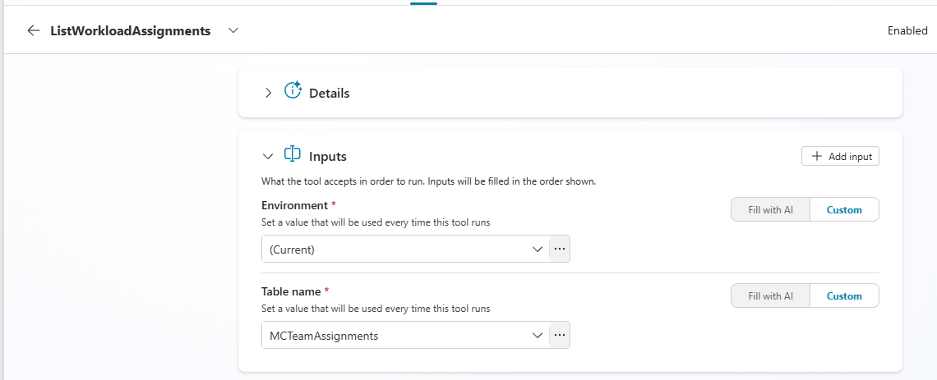
  - Save & Publish Changes

Optional Roadmap MCP:The Agent has one MCP server connection configured this is optional and it can be deleted if you choose.
- Get started with the Microsoft Release Communications MCP Server - Microsoft 365 admin | Microsoft Learn

Testing the agent:

At this time the agent should be configured and ready to go. If you have the Planner Sync setup and Message Center posts in Planner you can simply prompt the agent to “Help triage” and it will triage the post.

For example:

Help me triage MC1309733

Provide a table of all Workload Assignments

Tell me about roadmap ID 499660

